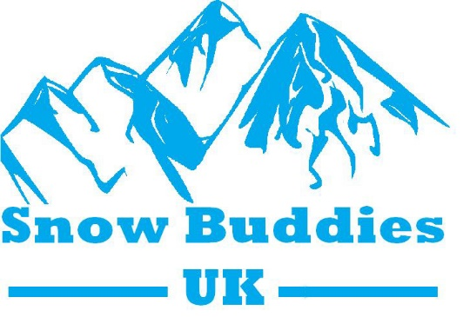 | 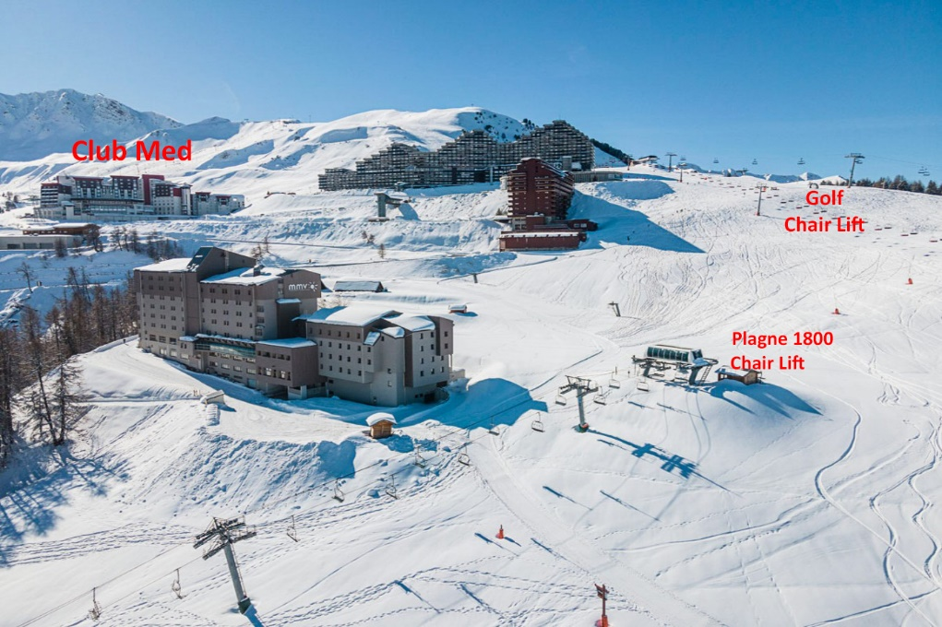
General Information – Terms and Conditions
2025
08 to15 March – MMV Hotel Aime 2000
High in La Plagne, Above Plagne Centre
Booked with Crystal Ski
(Please note this is a Saturday to Saturday trip)
For
Disabled skiers, Helpers, PSA’s, (Friends & Family Members space permitting)
Self-Drive or fly Gatwick, Bristol, Birmingham and Manchester.
- For blue/red run independent disabled skiers  - Fully dependent piloted duel skiers  - Sit skiers who need assistance  - Tuition provided at an extra cost | - door-step skiing  - High in the La Plagne ski area.  - 3 x twin wheelchair friendly rooms  - No off-piste skiing  - Very social

The Hotel.
Facing the Mont-Blanc, entirely renovated, your Hotel Club offers more comfort, a contemporary decoration and pleasant rooms, including family mini-suites which can accommodate up to 5 people
Enjoy a varied cuisine and Savoyard dishes in the restaurant. At the end of the day, relax at the Espace Aqua relaxant with sauna, and its Spa with massages and treatments. The Club Plagne 2000 hotel in La Plagne is on the blue Golf ski slope and is ski-in/ski-out.

La Plagne, Aime 2000.
Is a winter sports resort located opposite Mont Blanc, at an altitude of 2100 metres. Considered by many to be one of the best resort villages in the Alps, La Plagne, Aime 2000 offers spectacular views over the Tarentaise Valley thanks to its unique location. La Plagne, Aime 2000 is one of ten resort villages in the ski area known as La Grande Plagne, and one of its six mountain villages. Organised around its snow front, Aime 2000 is a welcoming village that provides skiers with direct access to the Paradiski ski area, where you’ll find 425 km of marked runs for all abilities. With its numerous facilities.

Priorities.
Priority will be given to those disabled skiers and snowboarders for whom other ski trips are unsuitable and their only opportunity to ski is with Snow Buddies.

Accommodation.
Snow Buddies have pre-booked 24 spaces for the 2025 ski trip. By default, the accommodation that we book is twin rooms.
- Divided family rooms are limited but available.
- A limited number of wet rooms are available if required.
- Single occupancy might be available on request and payment of the under-occupancy surcharge.
To Travel with Snow Buddies.
1. Helpers.
- Ski ability,
    - Helpers must be competent red run skiers confident when skiing in adverse conditions (whiteouts).
    - Have a good understanding of mountain safety and accident procedures.

- Travel,
Except for those self-driving to resort. Be available to help with luggage and equipment at: -
    - Airports
    - Coach transfers
    - The hotel

- In the hotel,
    - Assisting as required in the hotel, most critically at meal times.

- On the mountain.
    - Assisting as required all day when out skiing, providing help with lunch and coffee/hot chocolate breaks during the day.

- Adaptive skiing,
    - Have an interest in disability and adaptive skiing.

- Social,
    - Maybe most importantly all helpers must have a sense of humour and be willing to mix socially with the whole group.

- Prices,
    - The Snow Buddy prices are offered with the understanding that helpers will fully participate in the trip and help where and when required.
- Availability,
    - Places are dependent on the number of disabled skiers on the trip and their requirements, places must be confirmed by Snow Buddies and the deposit paid before any place is definite.

2. Skiers.
- Decision making,
    - The skier must be capable of making their own decisions and be happy to engage with the trip organizers by phone and/or email.
or;
    - The person fulfilling this role on behalf of the skier will be accompanying them on the ski trip.

- Personal care,
    - Any skier that needs a PSA to assist with personal care and/or support in the hotel must make their own arrangements (with the agreement of Snow Buddies UK) prior to booking a trip, consideration must be given to care on the ski slopes as well as care in the hotel.

- Ski ability,
    - A skier must independently be able to ski blue / easy red runs safely and competently or agree to the extra cost of ski lessons before they can be considered for a place on a Snow Buddies trip.
    - Note: - If there is any doubt about ski ability a ski session at Tamworth Snow Dome must take place before any ski trip decisions can be made, except;
    - Those who need to use a Tessier piloted duel ski, these skiers will be allocated places dependant on equipment, Tessier pilot availability and at the discretion of Snow Buddies UK trip organisers.

- Enforced stayover,
If for any reason a skier cannot return to the UK at the end of a ski trip, they must be capable of, but not exclusively,
    - Supporting themselves for an extended period of time in resort.
    - Making all onward travel arrangements.
    - Making arrangements to pay any bills incurred by the extended stay.
or;
    - Provide Snow Buddies UK with a copy of their support plan that achieves all of the above.

- Fundraising,
    - As a condition of traveling with Snow Buddies all skiers will be expected to fundraise for Snow Buddies the first year that they travel and at a minimum every subsequent 3rd year.
3. PSA’s.
All skiers who require support in the hotel must provide their own PSA’s, (in consultation with Snow Buddies trip organizers).

4. Family Members/Friends.
- Family members and friends are welcome on Snow Buddies ski trips with the following conditions;
          - As long as there are available places in the hotel etc.
          - There are no discounts available for family members and friends.

5. The Cost and Payments.
- To Fly,
    - Includes – Hotel full board, wine with the evening meal, coffee and cake in the afternoon, Flight from chosen airport (The surcharge from Bristol, B’ham and Manchester is TBC), Coach Transfers, 6 day La Plagne lift pass with Carre Neige insurance cover.
    - NOTE 1: Does not include equipment hire, ski carriage or flight suppliments

- Self-Drive,
    - Includes – Hotel half board, wine with the evening meal, coffee and cake in the afternoon, 6 day La Plagne lift pass with Carre Neige insurance cover.
    - NOTE 1: Does not include equipment hire and car parking.
    - NOTE 2: Self-drive discount from the prices below will be £75.00 pp.

 |  | Deposit  to secure a place | Main payment  By 01 Dec 2024 |  |  |  | Total
Skier |  | £200 | £1000 |  |  |  | £1200
Returning Helper |  | £200 | £600 |  |  |  | £800
First Time Helper |  | £200 | £800 |  |  |  | £1000
PSA (Does not include a lift pass) |  | £200 | £600 |  |  |  | £800
Friend/Family |  | £200 | £1100 |  |  |  | £1300
Mono/duel ski hire |  |  |  |  | £200
 | Want to know more ring Andy on 07868 660756

How to Pay

Cheques | BACs payment
Cheques made payable to Snow Buddies UK  and sent to;  30 Prescelly Close, Nuneaton, CV10 8QA | Account Name Snow Buddies UK  Account No Sort Code 54225160 30-84-79

6. Payment Conditions.
- The initial deposit of £200 is required before you can be allocated a place on the trip.
- If you pull out of the trip deposits are non-refundable unless a suitable replacement to fill the place can be found who is acceptable to Snow Buddies UK.
- All prices are approximate and subject to change.
- Places are dependent on suitable hotel accommodation and ski buddy availability.
- The Ski Buddy prices are offered with the understanding that helpers will fully participate in the trip and help where and when required.

7. Discounts.
There are no discounts from the ski trip price but a small amount of money has been put to one side to help any skier struggling with cost incurred by their disability like, travel insurance, equipment and PSA costs.

8. Cancellations.
- Deposits and main payments are non-refundable unless a suitable replacement to fill the place can be found.
- Suitable replacements are entirely at the discretion of Snow Buddies UK.
- If for reasons out of Snow Buddies control, a trip has to be cancelled, refunds are not guaranteed.

9. General Conditions.
- Disabled skiers must bring proof of disability (blue card etc.) so a reduction can be claimed on the lift passes. (Failure to provide proof of disability will incur a charge of £250.00).
- There may be changes in the price as the value of Sterling fluctuates.
- All participants must have adequate holiday/ski insurance.
- The cost and provision of carers is the disabled skiers’ responsibility.
- Skiers who require care in the hotel must consider the same level of care when skiing.
- We have to maintain the correct ratio of Helper to Skiers, no Skier’s or helpers place is guaranteed until this ratio is met.
- If there is no suitable ski Buddy the deposit will be refunded in full.
- Snow Buddies does not provide for ski lessons, ski guiding and off piste skiing.
- Everyone wishing to travel with Snow Buddies must complete the relevant questionnaire before they can be offered a place on a ski trip.

10. Insurance.
- All Helpers, Skiers, PA’s and family members are responsible for their own travel insurance with adequate winter sports cover for the duration of the trip.
- All lift passes purchased by Snow Buddies will include carre neige insurance cover. This is not in lieu of your personnel winter sports cover but an addition, for more info go to; https://carreneige.com/en/

11. Equipment Hire.
- Ski equipment can be booked from Ski Set who have a shop at MMV Hotel Aime 2000. Details will be distributed closer to the date.
- Snow Buddies have a number of Tessier Tempo Mono and Dual skis that are available for the ski trip (book early).
12. Flight Info.

Flight info will be confirmed when airports have been confirmed.

13. Please Note.
These terms and conditions are for guidance and cover the salient points, if in doubt please ask before committing to a trip.

Updated on 01 May 2024

